1. Write a c++ program to create a class for a bank account with a constructor and a destructor
2. 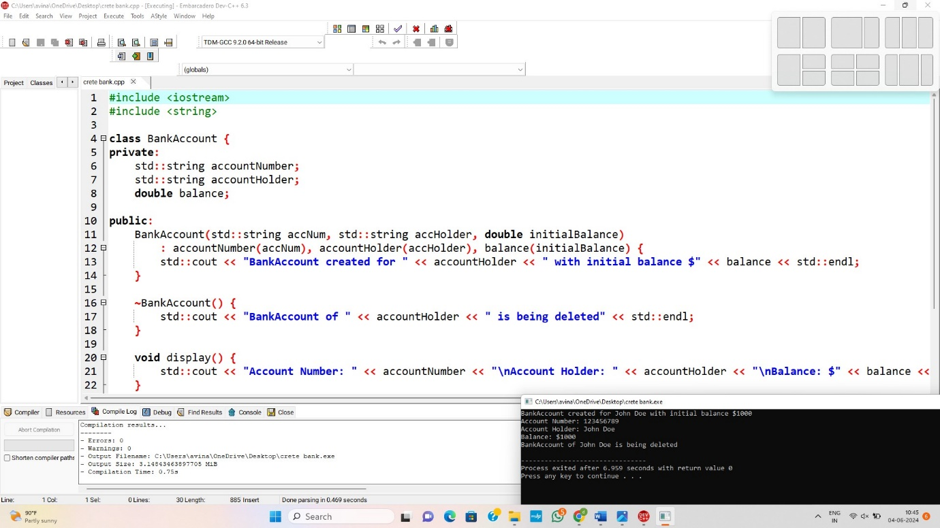

2. Write a c++ program to create a class for a car with a constructor and a destructor

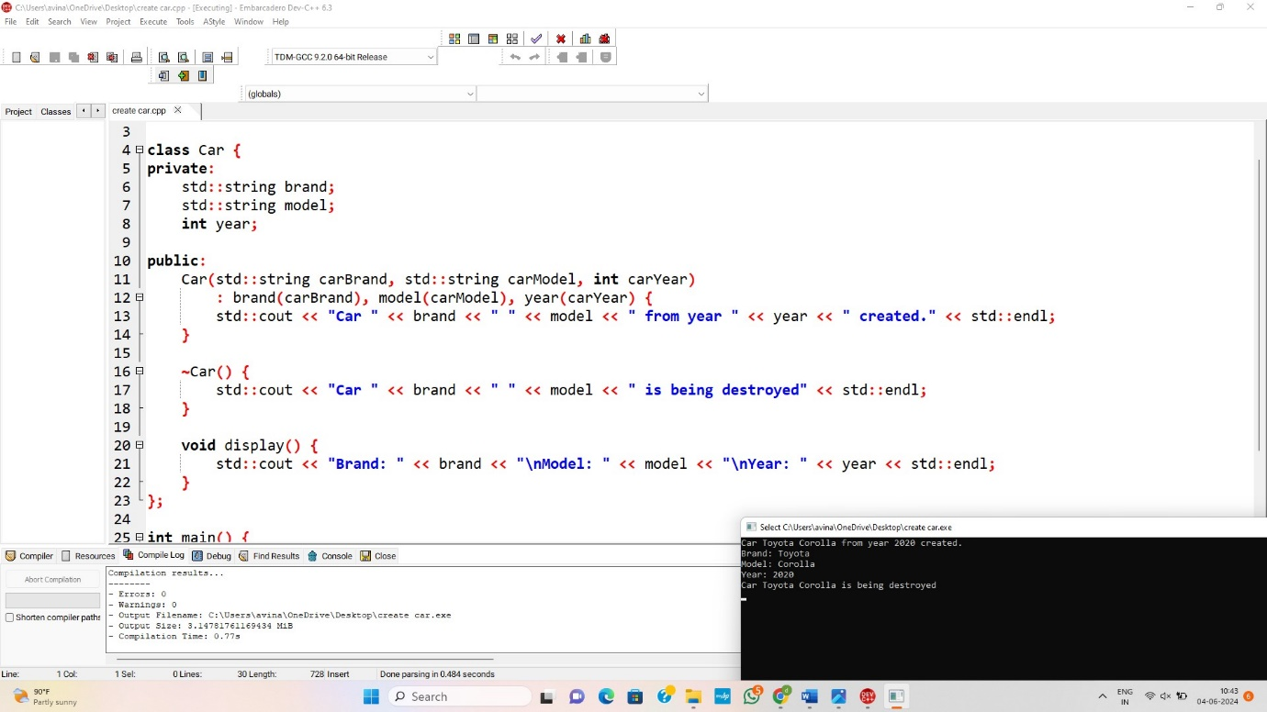

3. Write a c++ program to create a class for a rectangle with a constructor and a destructor

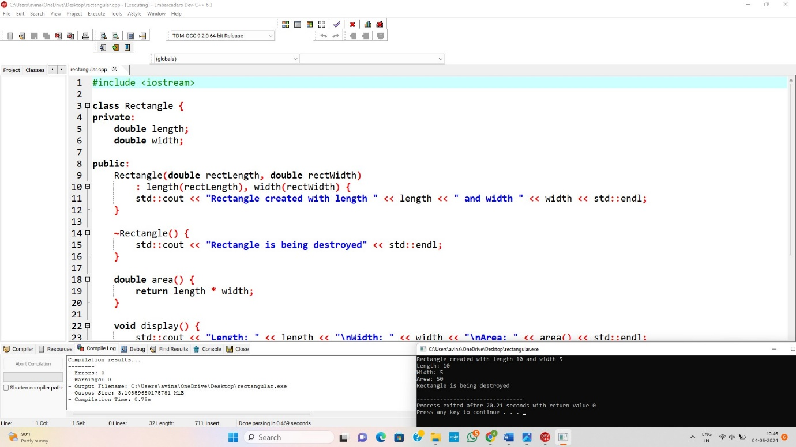

4. Write a c++ program to create a class for a book with a constructor and a destructor

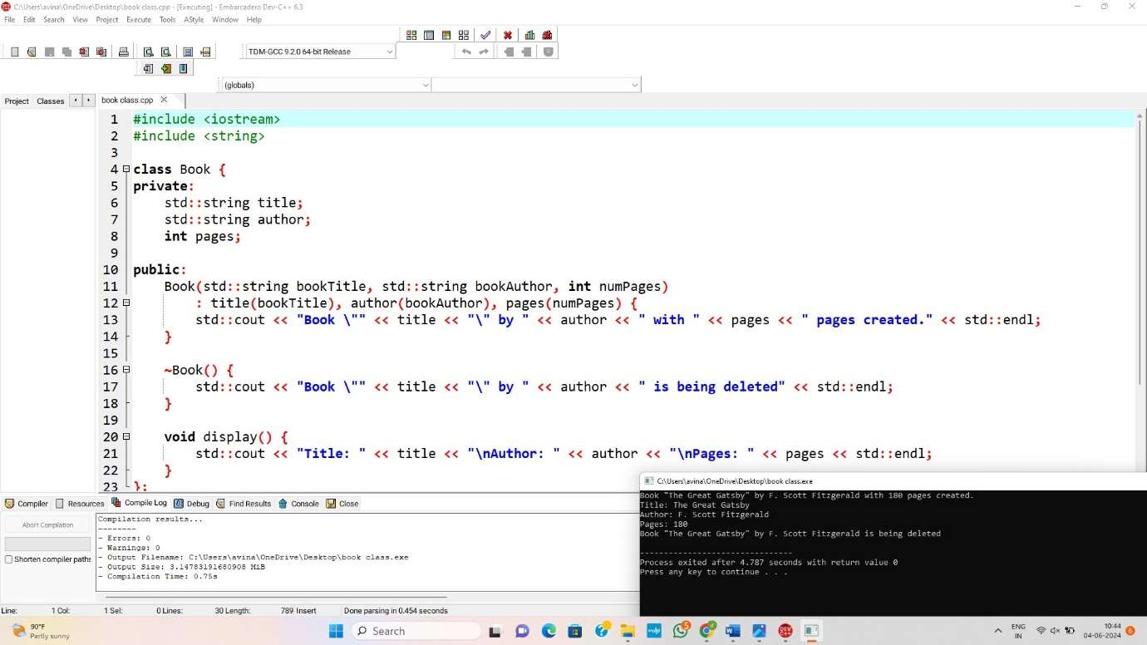

5. Write a c++ program to create a class for student with a constructor and a destructor

